THEOSIS / DIVINIZATION

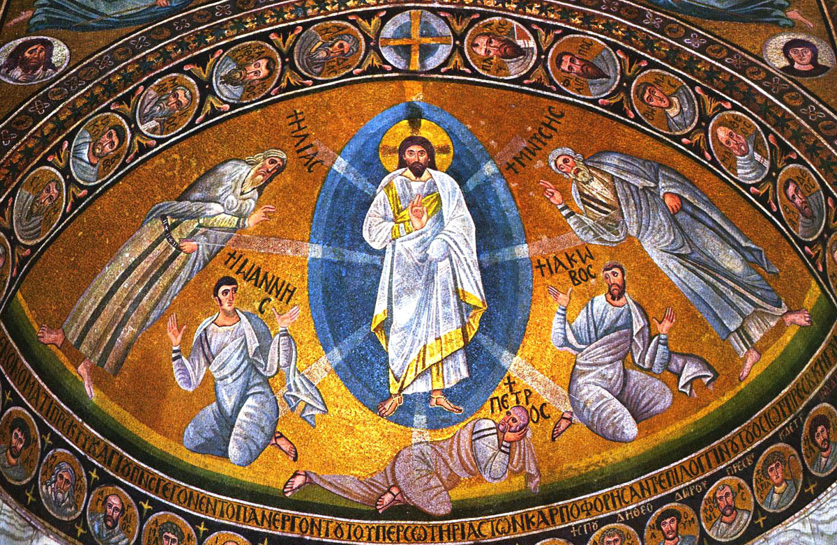
Transfiguration, mosaic, St. Catherine’s Monastery, Sinai , 6th cent.

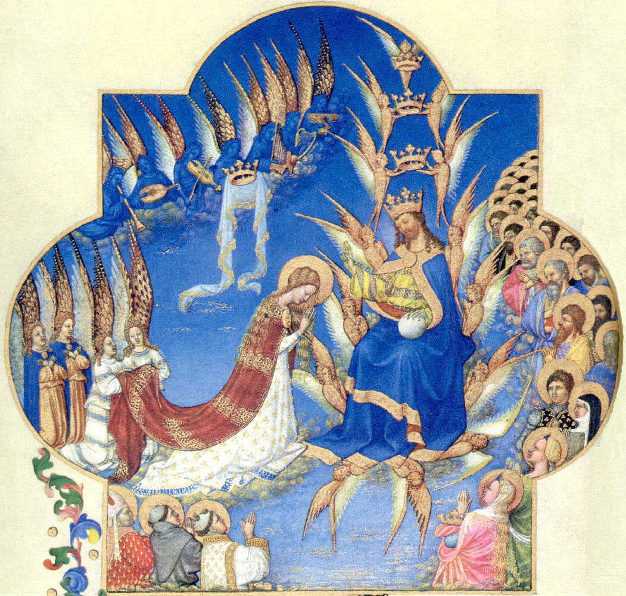
Coronation of the Virgin. Duc de Berry, Très Riches Heures. c. 1414

http://ldysinger.stjohnsem.edu/ [“Retreats”; “Apokatastasis…”] ldysinger@stjohnsem.edu
APOKATASTASIS / RESTORATION

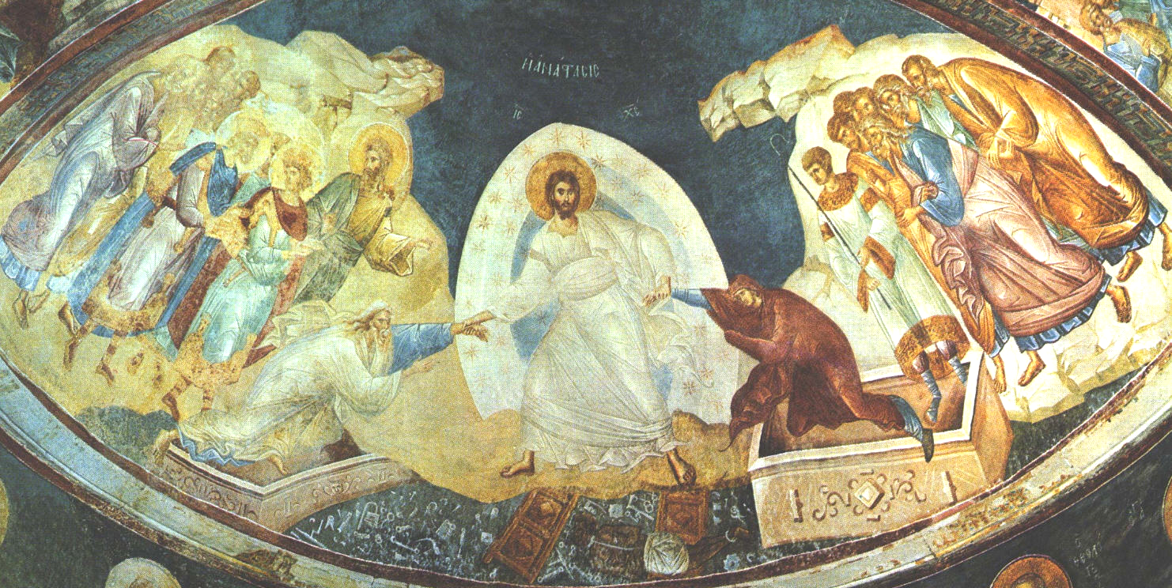
Anastasis (“Resurrection”), fresco, Chora Monastery, Constantinople/Istanbul, 14th c.

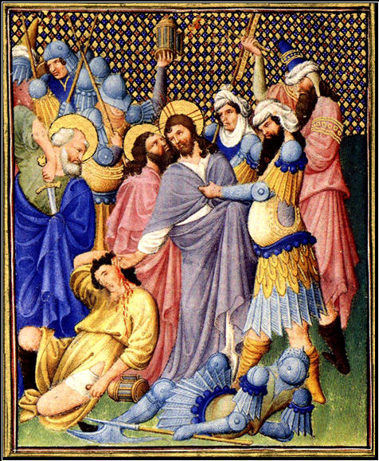
Betrayal in the Garden, Duc de Berry, Belles Heures. c. 1407

